2023 Grand Marshal Nomination Form
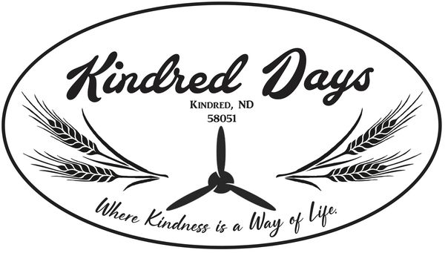

Grand Marshal nominees shall be Kindred area residents and have been committed to community growth, support, and service.
Name
Email/ Phone

I nominate because,

May we contact you about your submission? | YES NO

